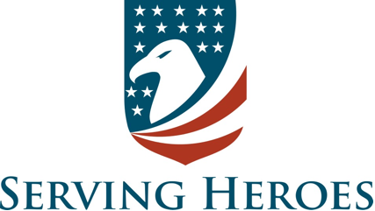

**Testimonials**

**From the United States Air Force**

I learned so much there is too much to repeat. I can’t think of any improvements. I am going to attend all 7 levels.

Gen. Greg Gardner(Ret.)

**From the Kansas City Missouri Police Department**

Chaplain Barry Young has been critical to the formation and training of the Chaplain Unit at the Kansas City MO Police Department. We were so impressed with Chaplain Young’s training we have invited him back to train our Chaplains. I couldn’t give Chaplain Young a higher or better recommendation! If you have any questions, please contact me.

Officer Jason Cooley - Lead Community Interaction Officer

**From the Deltona Beach Fire Department**

The guidelines for debrief/defuse are awesome. All of the information was great, and I am eager to take it back to my agency. I enjoyed everything and gained a great deal of useful information.

Lt. Heather Langston - Firefighter/Peer Support Team Member

**From Crossroads Hospice in Salt Lake City Utah**

Barry is an incredibly dynamic speaker with a passion for this topic and for helping others. Anyone who attends his training will walk away with meaningful information and renewed passion.

Sherri Bickley - Vice-President of Patient Support Services

**From the Republic MO Police Department:**

This was one of the most dynamic trainings I have been to in my 23 years of law enforcement. It was packed full of very simple yet very effective and applicable information for both personal and professional growth and development!

Sgt. Jeff Romero

**From the Nassau County FL Sheriff’s Department**

I had the privilege of taking Barry Young's Chaplain Training and I would recommend it to any church, association, or first responder agency. Barry gave us an abundance of practical tips, tools, and techniques to serve and provide emotional assistant to First Responders.

Dr. David Drake - Senior Chaplain

**From RTD-Denver Colorado**

Very knowledgeable.  The passion behind the delivery was phenomenal which you don’t always find in classes I attend.

Sgt. Jessica Chaine

**From the United States Army**

Barry is not only an expert, but he brings a wealth of experience/humor and teaches with dynamic energy!

Col. Donald Mondragon

**From the Denver CO Fire Department**

I loved the real/authentic way of presenting.

Lt. Derrick Johnson

**From the Beaufort SC Sheriff’s department.**

I learned A LOT. Things I can share with command staff, my negotiations team, our chaplains, and others.

Sgt. Danny Allen

**From the Lincoln NE Police Department**

This class is fast-paced, efficient, and full of critical information for anyone called to love and serve others; especially first responders.  It is real life, practical, and so encouraging.

Lead Chaplain Deb Badeer

**From the Nixa MO Fire Department**

I appreciate that you got to the point of things.  I appreciate the concrete tools, the lack of "fluff", the real world examples, and your down to earth approach.

Dr. Lynne Schenk